Scripture, Prayers, and Music
When we’re Struggling with Mental Illness
FCUCC

Scripture

- Psalm 23 (NKJV)
The Lord is my shepherd;
I shall not want.
He makes me to lie down in green pastures;
He leads me beside the still waters.
He restores my soul;
He leads me in the paths of righteousness
For His name’s sake.
Yea, though I walk through the valley of the shadow of death,
I will fear no evil;
For You are with me;
Your rod and Your staff, they comfort me.
You prepare a table before me in the presence of my enemies;
You anoint my head with oil;
My cup runs over.
Surely goodness and mercy shall follow me
All the days of my life;
And I will dwell in the house of the Lord
Forever.

One member has said that the 23rd Psalm is what helps them get through the hard times. They said, “there is something about "He restoreth my soul" that has such strength for me. It comforts me and really helps with my symptoms.”
Another commentator has said: A biblical image that underscores our calling to provide support to those who are disconnected and who may be vulnerable is in Psalm 23. We think about a Shepherd who holds and is rocking the lamb. Also, there is the rod and the staff of the Shepherd that provides comfort as well as signs of strength in face of opposition. They are used to fight off the dangers. The Shepherd prepares a table in the presence of one’s enemies. This is a Shepherd who advocates for the vulnerable, who protects the hurting, and who creates that place where there is calm and rest.

- Psalm 30: 1-5 (NASV)
A Psalm. A Song at the dedication of the temple of David.
¹ I will extol you, O Lord, for you have drawn me up,
and did not let my foes rejoice over me.
² O Lord my God, I cried to you for help,
and you have healed me.
³ O Lord, you brought up my soul from Sheol,
restored me to life from among those gone down to the Pit.
⁴ Sing praises to the Lord, O you his faithful ones,
and give thanks to his holy name.
⁵ For his anger is but for a moment;
his favor is for a lifetime.
Weeping may linger for the night,
but joy comes with the morning.

I have found these passages in Psalm 30 to help when times are tough:

- Psalm 42 (NRSV)

As a deer longs for flowing streams,
so my soul longs for you, O God.
My soul thirsts for God,
for the living God.
When shall I come and behold
the face of God?
My tears have been my food
day and night,
while people say to me continually,
“Where is your God?”
These things I remember,
as I pour out my soul:
how I went with the throng,
and led them in procession to the house of God,
with glad shouts and songs of thanksgiving,
a multitude keeping festival.
Why are you cast down, O my soul,
and why are you disquieted within me?
Hope in God; for I shall again praise him,
my help and my God.
My soul is cast down within me;
therefore I remember you
from the land of Jordan and of Hermon,
from Mount Mizar.
Deep calls to deep
at the thunder of your cataracts;
all your waves and your billows
have gone over me.
By day the Lord commands his steadfast love,
and at night his song is with me,
a prayer to the God of my life.
I say to God, my rock,
“Why have you forgotten me?
Why must I walk about mournfully
because the enemy oppresses me?”
As with a deadly wound in my body,
my adversaries taunt me,
while they say to me continually,
“Where is your God?”
Why are you cast down, O my soul,
and why are you disquieted within me?
Hope in God; for I shall again praise him,
my help and my God.

This recognizes that "my soul is disquieted" and moves to hope, but gently, not insisting that I get there by the end of the psalm but helping me remind myself that I will come to praise God again.

- Isaiah 43:1-4
But now thus says the Lord,
he who created you, O Jacob,
he who formed you, O Israel:
Do not fear, for I have redeemed you;
I have called you by name, you are mine.
When you pass through the waters, I will be with you;
and through the rivers, they shall not overwhelm you;
when you walk through fire you shall not be burned,
and the flame shall not consume you.
For I am the Lord your God,
the Holy One of Israel, your Savior.
I give Egypt as your ransom,
Ethiopia and Seba in exchange for you.
Because you are precious in my sight,
and honored, and I love you,
I give people in return for you,
nations in exchange for your life.

This can be used as a clobber verse--Just don't fear!--but a pastor introduced me to this passage when I was feeling overwhelmed. It communicates God's loving presence and some reassurance (though v 4 can be a bit problematic as far as giving other people in exchange...).

- Ecclesiastes 3:9-22
What gain have the workers from their toil? I have seen the business that God has given to everyone to be busy with. He has made everything suitable for its time; moreover he has put a sense of past and future into their minds, yet they cannot find out what God has done from the beginning to the end. I know that there is nothing better for them than to be happy and enjoy themselves as long as they live; moreover, it is God’s gift that all should eat and drink and take pleasure in all their toil. I know that whatever God does endures forever; nothing can be added to it, nor anything taken from it; God has done this, so that all should stand in awe before him. That which is, already has been; that which is to be, already is; and God seeks out what has gone by.
Moreover I saw under the sun that in the place of justice, wickedness was there, and in the place of righteousness, wickedness was there as well. I said in my heart, God will judge the righteous and the wicked, for he has appointed a time for every matter, and for every work. I said in my heart with regard to human beings that God is testing them to show that they are but animals. For the fate of humans and the fate of animals is the same; as one dies, so dies the other. They all have the same breath, and humans have no advantage over the animals; for all is vanity. All go to one place; all are from the dust, and all turn to dust again. Who knows whether the human spirit goes upward and the spirit of animals goes downward to the earth? So I saw that there is nothing better than that all should enjoy their work, for that is their lot; who can bring them to see what will be after them?
This has been helpful (as has all of the book of Ecclesiastes) because it shows me that I am not alone when I really feel depressed about my life and about the world. It reminds me that we are given little things in life, like eating and drinking and resting, or big things, like our jobs, so that we can find happiness even in the midst of trouble. It helps me focus on enjoying those things.

- Jeremiah 29:11
For I know the plans I have for you,” declares the Lord, “plans to prosper you and not to harm you, plans to give you hope and a future.

I have struggled with anxiety and borderline personality disorder my whole life. This verse helps me to remember that God has a path set for me and that, even when I am at my lowest, there is hope for me.

- Philippians 4:6-7
Do not worry about anything; instead, pray about everything. Tell God what you need, and thank him for all he has done. Then you will experience God’s peace, which exceeds anything we can understand. His peace will guard your hearts and minds as you live in Christ Jesus.

I am thankful that MOST of the time, I do not have the burden of mental health struggles. But for the times when I am over-stressed, sad, or anxious, this passage has been comforting.

- Romans 8:38-39
For I am convinced that neither death, nor life, nor angels, nor rulers, nor things present, nor things to come, nor powers, nor height, nor depth, nor anything else in all creation, will be able to separate us from the love of God in Christ Jesus our Lord.

Nothing can separate me from God's love, even my internal barriers.

- 1 John 1: 9
“If we confess our sins, he is faithful and just and will forgive us our sins and purify us from all unrighteousness”.
I was feeling anxiety and depression through all of the Covid changes and the uncertainty of the many changes in my life. I felt I had sinned. I was a disappointment and deserved to be punished, which also led to feelings of self-harm and suicidal ideations.
Like your sermon said, being strong enough to reach out and admit I needed help from professionals, to see I am stronger for doing so, and feeling the love and comfort of those who do not judge, but offer me love, and reading the Bible and finding this verse—it all helped. It helps to know that we all need each other and when we struggle, hands are ready to give us support.

- John 14:27
Peace I leave with you; my peace I give to you. I do not give to you as the world gives. Do not let your hearts be troubled, and do not let them be afraid.

Sometimes I've heard people use this to clobber others--Just don't be afraid!--which is not so helpful, but I find it helpful as a reminder of Christ's peace and that others have been afraid before me.

Prayers

- The Serenity Prayer

God, grant me the serenity to accept the things I cannot change,
courage to change the things I can,
and wisdom to know the difference.

This is the first prayer I ever learned and the one I go back to in order to calm myself. Anxiety and fear is crippling. However, life happens and there are things in this world we cannot control. We have to keep pushing forward. What I can control is myself and my actions and making a difference in another person’s life....

- The Merton Prayer
My Lord God,
I have no idea where I am going.
I do not see the road ahead of me.
I cannot know for certain where it will end.
nor do I really know myself,
and the fact that I think I am following your will
does not mean that I am actually doing so.
But I believe that the desire to please you
does in fact please you.
And I hope I have that desire in all that I am doing.
I hope that I will never do anything apart from that desire.
And I know that if I do this you will lead me by the right road,
though I may know nothing about it.
Therefore will I trust you always though
I may seem to be lost and in the shadow of death.
I will not fear, for you are ever with me,
and you will never leave me to face my perils alone.
This prayer by Thomas Merton says what I sometimes want to say to God when I'm feeling lost.
The Merton Prayer” from Thoughts in Solitude Copyright © 1956, 1958 by The Abbey of Our Lady of Gethsemani. Used by permission of Farrar Straus Giroux. Reflections journal is produced twice a year as a public service of Yale Divinity School. Each free issue seeks to bring theological insight to a contemporary social, political or religious question. https://reflections.yale.edu/article/seize-day-vocation-calling-work/merton-prayer

3.


I hope you’ve not forgotten,
how magical life can be.
It’s understandable if you have.
Your soul is depleted, weary and worn,
But remember life is capable of so many twists and turns.
And nothing, nothing, is permanent.
As fast as you can feel at your very end,
life can throw out a rope and pull you,
To the highest of heights.
It’s a rollercoaster.
An up and down, in and out, over and under ride.
This chapter in your story is almost through
And if you can just cast your mind back to the magic,
Your silver lining will find you, pretty soon.
And I think it’s going to be the most magical time in your life,
You’ve come so far and taken so much.
I hope you’ve not forgotten how magical life can be my friend.
You must believe.
--Donna Ashworth
--Artwork by Ira Mitchell-Kirk

4.
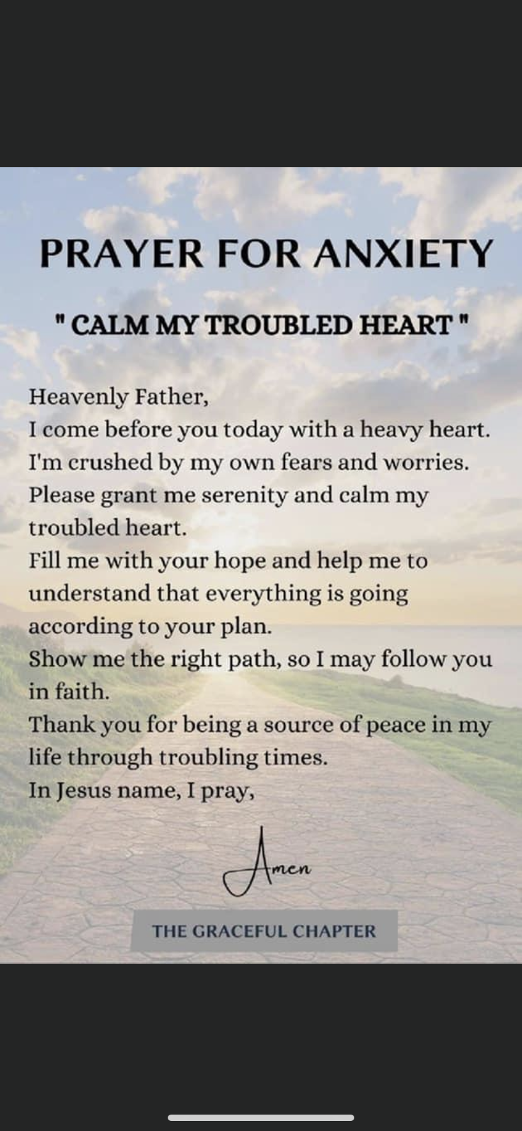

Songs
- Cantus Mundi: When we are called to sing your praise (KINGSFOLD)
You can also find it here: https://www.youtube.com/watch?v=ByETbBeQ8RI&t=1s
Absolute hands-down most helpful for me has been "When We Are Called to Sing Your Praise", which was written by someone in the UCC. Churches were given permission to use it for a time following 9/11 (which is where I heard it for the first time and then memorized it). This puts words to my can't-find-words prayer.

- "Out on this Wire" by Christopher Grundy: https://www.youtube.com/watch?v=F1UHNaFkqH0

A really good song that might connect for younger folks (on the Here in Providence album). "Out on this Wire" speaks to reaching for God's hand in the anxieties and pressures and overwhelmed-ness of multiple roles (but written from an adolescent's view... school, job, sports, appearance, sexuality are among those addressed).

- Here in Providence by Christopher Grundy on Amazon Music - Amazon.com

 | Here in Providence  Here in Providence

You can also find it at: https://www.youtube.com/watch?v=ZqKsggw7mdM

"Here in Providence" speaks about bad things that happen and finding hope... it portrays two unresolved situations of a broken world (a woman who travels a long distance to be with her dying father and he dies when she's not quite there but "in the elevator 100 yards away" and a Black man who faces hardships, and after singing in church "goes home, all alone, to watch the millions dying on the news") and then one with some resolution--a man who "walked out on his family late one night, with a bottle and a gun" but stumbles across a woman who's been beaten "so bad it made him wince" and gets her to the hospital and goes home safely.

- Waymarks (Songs for the Journey) by Northumbria Community on Amazon Music - Amazon.com

Waymarks (Songs for the Journey)
Waymarks (Songs for the Journey)

This song has been helpful during the pandemic. Someone introduced me to this in a supportive online group early in COVID. "Even Though the Day be Laden" by the Northumbria community on the Waymarks: Songs for the Journey album. It acknowledges that feeling of being overwhelmed "... the day be laden and my task dreary and my strength small" and starts out dragging, but as more and more voices get added, it slowly becomes cheerful.

- "Dust and Ashes Touch Our Face" by David Haas. I want to share a song that I'm ambivalent about. I hate to withhold something that really was helpful to me, but the songwriter/artist has now had multiple women accuse him of sexual misconduct. The song is in our hymnal, 186 Especially v 3--how many other hymns specifically mention being "in the wasteland of depression"? It's validating and offered words to reach to God when I needed them.

- “His Eye Is on the Sparrow”

Why should I feel discouraged
Why should the shadows come
Why should my heart feel lonely
And long for heaven and home
When Jesus is my portion
A constant friend is He
His eye is on the sparrow
And I know He watches over me
I sing because I'm happy
I sing because I'm free
His eye is on the sparrow
And I know He watches me
His eye is on the sparrow
And I know He watches me
I am thankful that MOST of the time, I do not have the burden of mental health struggles. But for the times when I am over-stressed, sad, or anxious, the two passages below have been comforting. Certainly this past year has been stressful and difficult for many; I’m no exception. I’m a musician and performer and not being able to do those things (with others, in public) was beyond hard. A huge piece of my life was missing and it was like that “therapy” was out of reach! Now fully vaccinated, I’m just starting to get together again with musician friends I have dearly missed.

This song inspired by the words of Jesus: “Look at the birds of the air; they neither sow nor reap nor gather into barns, and yet your heavenly Father feeds them. Are you not of more value than they?” (Matthew 6:26) and “Are not two sparrows sold for a farthing? And one of them shall not fall on the ground without your Father. But the very hairs of your head are all numbered. Fear ye not therefore, ye are of more value than many sparrows.” (Matthew 10:29-31).

